Quiz# 3

Saad Ahmad

20P-0051

Question#2

1. Based on the topology, how many subnets are needed?

7

2. How many bits must be borrowed to support the number of subnets in the topology table?

4

3. How many subnets does this create?

16

4. Calculate the binary value for the first five subnets?

Net 0: 172 . 31 . 1 . ****0 0 0 0 0 0 0 0****

Net 1: 172 . 31 . 1 . ****0 0 0 1 0 0 0 0****

Net 2: 172 . 31 . 1 . ****0 0 1 0 0 0 0 0****

Net 3: 172 . 31 . 1 . ****0 0 1 1 0 0 0 0****

Net 4: 172 . 31 . 1 . ****0 1 0 0 0 0 0 0****

5. Calculate the binary and decimal value of the new subnet mask

Binary value: 11111111.11111111.11111111. ****1 1 1 1 0 0 0 0****

Decimal value: 255 . 255 . 255 . ****240****

6. Complete the Subnet Table, listing all available subnets, the first and last usable host address, and the broadcast address.

|  |  |  |  |  |
| --- | --- | --- | --- | --- |
| Subnet number | Subnet IP | First Usable Host IP | Last Usable Host IP | Broadcast Address |
| 0 | 172.31.1.0 | 172.31.1.1 | 172.31.1.14 | 172.31.1.15 |
| 1 | 172.31.1.16 | 172.31.1.17 | 172.31.1.30 | 172.31.1.31 |
| 2 | 172.31.1.32 | 172.31.1.33 | 172.31.1.46 | 172.31.1.47 |
| 3 | 172.31.1.48 | 172.31.1.49 | 172.31.1.62 | 172.31.1.63 |
| 4 | 172.31.1.64 | 172.31.1.65 | 172.31.1.78 | 172.31.1.79 |
| 5 | 172.31.1.80 | 172.31.1.81 | 172.31.1.94 | 172.31.1.95 |
| 6 | 172.31.1.96 | 172.31.1.97 | 172.31.1.110 | 172.31.1.111 |
| 7 | 172.31.1.112 | 172.31.1.113 | 172.31.1.126 | 172.31.1.127 |
| 8 | 172.31.1.128 | 172.31.1.129 | 172.31.1.142 | 172.31.1.143 |
| 9 | 172.31.1.144 | 172.31.1.145 | 172.31.1.158 | 172.31.1.159 |
| 10 | 172.31.1.160 | 172.31.1.161 | 172.31.1.174 | 172.31.1.175 |
| 11 | 172.31.1.176 | 172.31.1.177 | 172.31.1.190 | 172.31.1.191 |
| 12 | 172.31.1.192 | 172.31.1.193 | 172.31.1.206 | 172.31.1.207 |
| 13 | 172.31.1.208 | 172.31.1.209 | 172.31.1.222 | 172.31.1.223 |
| 14 | 172.31.1.224 | 172.31.1.225 | 172.31.1.238 | 172.31.1.239 |
| 15 | 172.31.1.240 | 172.31.1.241 | 172.31.1.254 | 172.31.1.255 |

Question#1

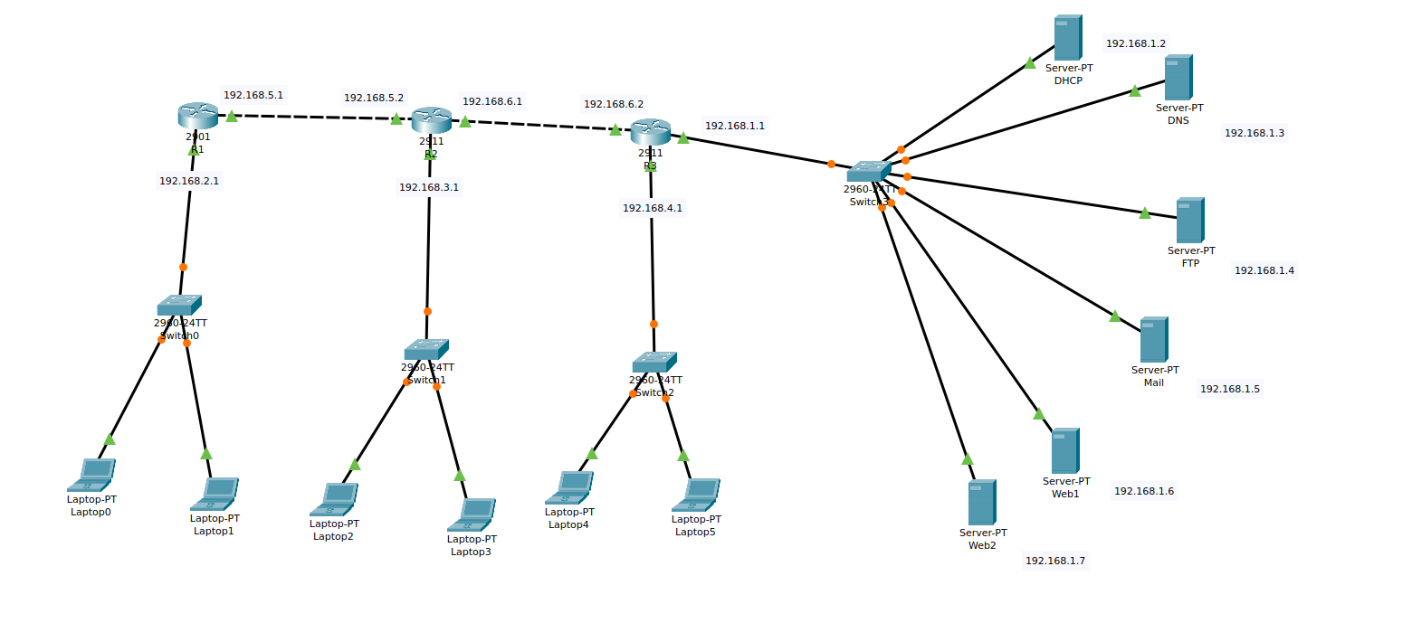

Configuring routers:

Router#1

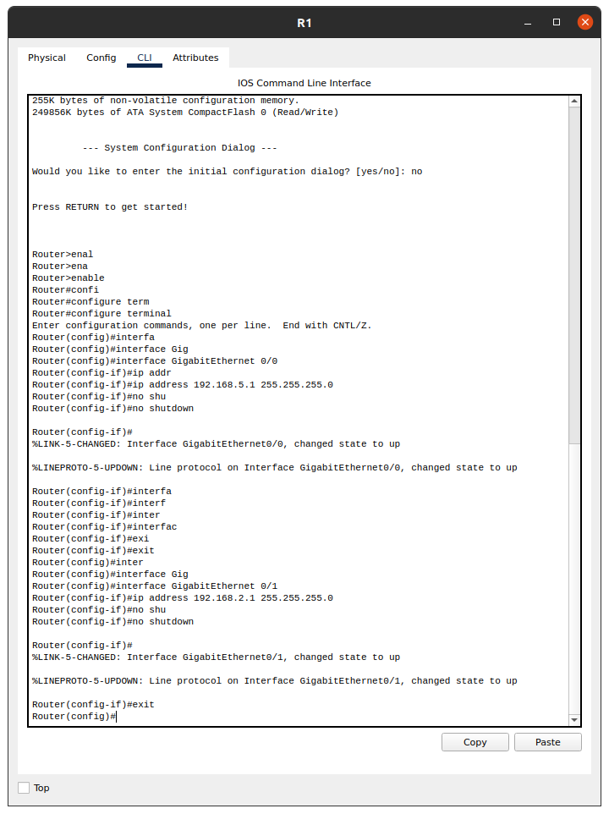

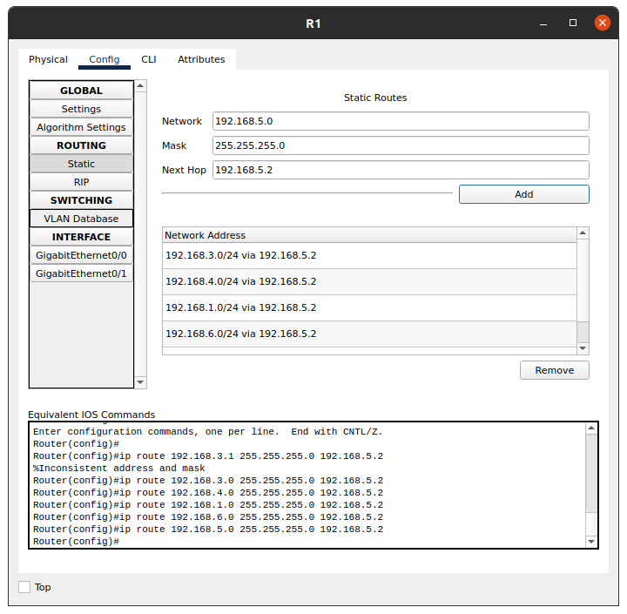

Router#2

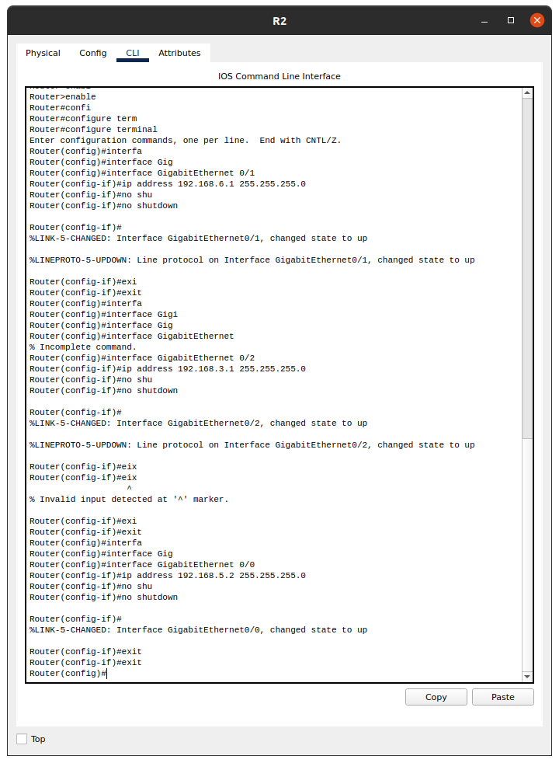

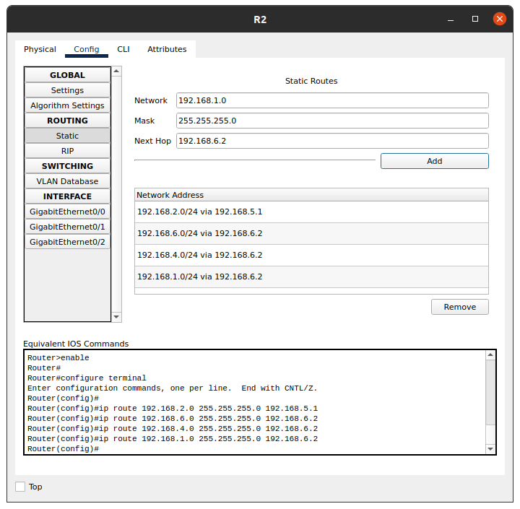

Router#3

